WALT Activities with Differentiated Choice Board
Mini Unit Plan – Muscles
Must do: 2 activities Should do: 4 activities Could do: 5 activities
We are learning to… identify leg muscles and explain their key use.
Genre | Without Device | With Device
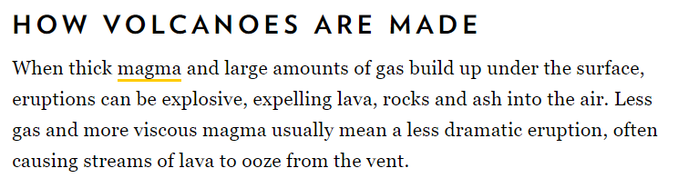  Writing / Reading | Use Table of Contents and Index to skim and scan selection of books in classroom.  Note take in 1B5s | Look up information using Google (see how to use Google chart on wall or on Class Notebook Contents page). Make a table and insert notes into own Class Notebook.
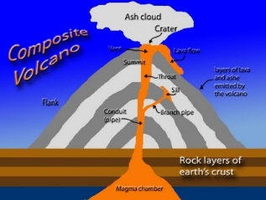  Visual | Draw an infographic.  It should be clearly labelled with muscles, as well as their uses. | Watch videos, including:  http://study.com/academy/lesson/leg-muscles-anatomy-support-movement.html  Paste clip into class notebook. Bullet-point key points in writing underneath.  Look up good, labelled images that help identify leg muscles. Add these to your class notebook.  Use any app/programme (eg: sway, PowerPoint/movie maker) to make a presentation about what you have found out. Upload to class Notebook.
Oral | Plan questions for an interview and make an appointment with a teacher or physiotherapist to ask your questions.  Notetake answers.  Talk to a peer about what you have discovered through other activities listed in this grid. Ask them if they have any questions. Add to your answers accordingly. | Listen to Leg Muscle song - https://www.youtube.com/watch?v=38qjXTltvTc  Add clip to class notebook.  Learn the words!  Do interview in “Without Device” box, record it and upload to notebook.  Make an audio recording of what you discovered through any of the other activities. Upload to your class notebook.
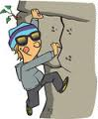  Kinaesthetic | Do a variety of exercises, taking note of the muscles you feel doing the most work for each. | Film a mate walking / running. Use slow mo to try to see the muscles working. Screen capture and label. Load onto notebook.
Mini Unit Plan –
Must do: 2 activities Should do: 4 activities Could do: 5 activities
We are learning to…
Genre | Without Device | With Device
Writing / Reading
Visual
Oral

Kinaesthetic

WALT Activities with/without device
Unit Plan – Short Story Study
Learning Objectives | Without Device | With Device
We are learning to describe physical setting using concise vocabulary | Draw the setting(s), labelling it with place names.  Add words to describe setting(s)  Use thesaurus to look up more concise words for essays. Add these to diagram.  Write sentences to describe setting.  Put these together in a paragraph. | Use Collaboration Space – work in pairs:  - Look up pics of setting (or similar types of places)  - List words to describe.  - Use thesaurus to add to list of words.  - Note down description of setting, then record this with Flipgrid (through Teams).  - Comment/critique/ask questions of the Flipgrids of others.
We are learning to explain how setting affects characters. | Draw a Venn Diagram to show how Fred and Jan were affected in different and similar ways by the war. | Nil
We are learning to write a paragraph explaining how setting affected ONE character. | Nil | Find annotated exemplar and checklist of what to include in paragraph on Class Notebook.  Write para on Word in One Drive.  Copy checklist over and place under para. Self-mark. Then share with a peer to mark also.  Finally, share with teacher.  Complete feedback table on your Class Notebook.

Unit Plan –
Learning Objectives | Without Device | With Device
We are learning to
We are learning to
We are learning to

Student Inquiry Planned Around NZ Key Competencies / 21C Skills
Unit Plan –Student Inquiry
Disposition | Students will… | Digital Tools
Caring for Self | Read feedback on practice exam answers.  Log this feedback on table provided in Class Notebook. | Class Notebook – student notes (Feedback tab)
Critical Thinking | Inquiry:  - Writing ‘good’ questions  - Research critically, completing Source sheets  - Process information  - Putting presentation together – deciding what to keep and what to throw.  - Reflecting throughout | - Work through:  - How to use Google  - Source reliability and bias  - Epic  - Ted Talks etc etc  - Team Files  - Students’ Class Notebooks for Reflection Entries.  - Class notebook contents library for sources / info  - Use Referencing Generator, or refer to APA Guide to reference correctly.
 | Writing:  Sharing and peer marking | - Word and OneDrive
 | Mindmap:  Summarise new learning | - Use https://www.text2mindmap.com if students want to OR on A3 paper.
Communicating | Inquiry:  - Discuss findings, collation and presentation development with group members.  - Interview at least one person.  - Survey online  - Construct and deliver presentation to class. | Teams – Group channel - chat  Phones or skype (could record face to face interview on phone, then upload to CNB)  MS Forms to conduct survey  Presentation app of their choice eg Sway, PowerPoint, video…  MS Edn Skype to see xyz
Collaborating | Inquiry:  Decide on Team/Group roles.  Save info on Team Channel Files.  Collaborate on collation and presentation of material.  Collaborate on creation aspect. | Teams – files and chat on group channels.
Contributing | Contribute to Team for Inquiry  Approach PaknSave Papamoa to speak to them about plastic bags in veg area and the sale of battery hen eggs and caged piggy pork.
Creating |  | Up to students – could, using whatever technology they need:  - Make a video to play to Manager  - Design pamphlets to give out to customers on way into store.  - Design strong paper bags….
Unit Plan –Student Inquiry
Disposition | Students will… | Digital Tools
Caring for Self
Critical Thinking
Communicating
Collaborating
Contributing
Creating

