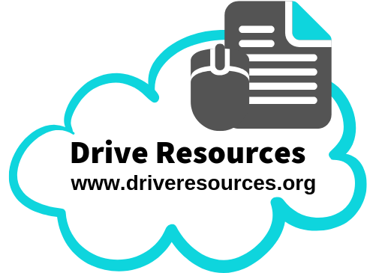
Essay checklist Level 1
For when you’re discussing just one thing
(eg one character or one idea)
 | I must do these things! | Intro/ Concln | Para 1 | Para 2 | Para 3
Introduction | Title underlined (long texts) or in quotation marks (short texts).
Introduction | Full name of author / director given (then referred to by last name if used in rest of essay).
Introduction | Gives brief synopsis (plot summary of 2-3 sentences)
Introduction | Answers first part of question (describing something), using key word from it (one sentence only).  Eg: The setting is a dystopian one where the environment is destroyed, and people are controlled by large corporations.
Introduction | Gives two sentences that answer the second part of the question (explaining something) using key word(s) from it.  Eg: This is important because… This is ALSO important because…
First body para to answer first part of question | Makes a Point in the first sentence:  - Answering the first part of the question (describing)  - Using key words from the question
First body para to answer first part of question | Provides an Example that helps the description.
First body para to answer first part of question | Describes clearly.
Further paragraphs (TWO) answering second part of the question | Makes a Point in the first sentence:  - Answers the second part of the question (explaining)  - Uses key words from the question
Give specific Example(s) (AKA evidence) to prove your point (such as quotations, film techniques, specific events, relationships etc). NOTE WELL:
- All quotations must be blended into your own sentence.
- Film essays MUST discuss film techniques!
 | Explanation of how your example supports your point (the one you made in the first sentence of this paragraph).
Linking your point to bigger ideas from the text!
You MUST have explained:
- The main idea (theme) that this illustrates (This shows THAT…
You COULD have explained things like:
- What this shows about a character, event, mood…
Stepping outside the text!
You MUST have explained:
- Author/director purpose (to…)
You COULD explain:
- What this tells you about human behaviours AND/OR
- How this relates to a historical event, current event or trend.
- How your point connects with something in a similar text
- Your personal response (we, us, readers/views)
Conclusion | Uses key word(s) from the question.
Conclusion | Title underlined (long texts) or in quotation marks (short texts)
Conclusion | Full name of author / director given.
Conclusion | Gives a summary statement about your essay/argument that includes author purpose and main idea.

Essay checklist Level 1
For when you’re discussing more than one thing
 | I must do these things! | Intro/ Concln | Para 1 | Para 2 | Para 3
Introduction | Title underlined (long texts) or in quotation marks (short texts)
Introduction | Full name of author / director given (then referred to by last name if used in rest of essay).
Introduction | Gives brief synopsis (plot summary of 2-3 sentences)
Introduction | Answers first part of question (describing something), using key word from it (one sentence only).  Eg: The setting is a dystopian one where the environment is destroyed and people are controlled by large corporations.
Introduction | Gives two sentences that answer the second part of the question (explaining something) using key word(s) from it.  Eg: This is important because… This is ALSO important because…
In each paragraph (At year 11 you should have 3) | Makes a Point in the first sentence:  - Answering the first part of the question (describing)  - Using key words from the question
In each paragraph (At year 11 you should have 3) | Give specific Example(s) (AKA evidence) to prove your point (such as quotations, film techniques, specific events, relationships etc). NOTE WELL:  - All quotations must be blended into your own sentence.  - Film essays MUST discuss film techniques!
In each paragraph (At year 11 you should have 3) | Explanation of how your example supports your point (the one you made in the first sentence of this paragraph).
In each paragraph (At year 11 you should have 3) | Makes another Point, but this time…  - Answers the second part of the question (explaining)  - Uses key words from the question
In each paragraph (At year 11 you should have 3) | Link your point to bigger ideas from the text!  You MUST have explained:  - The main idea (theme) that this illustrates (This shows THAT…  You COULD have explained things like:  - What this shows about a character, event, mood…
In each paragraph (At year 11 you should have 3) | Step outside the text!  You MUST explain:  - Author/director purpose (to…)  You COULD explain:  - What this tells you about human behaviours AND/OR  - How this relates to a historical event, current event or trend.  - How your point connects with something in a similar text  - Your personal response (we, us, readers/views)
Conclusion | Uses key word(s) from the question.
Conclusion | Title underlined (long texts) or in quotation marks (short texts)
Conclusion | Full name of author / director given.
Conclusion | Gives a summary statement about your essay/argument that includes author purpose and main idea.

