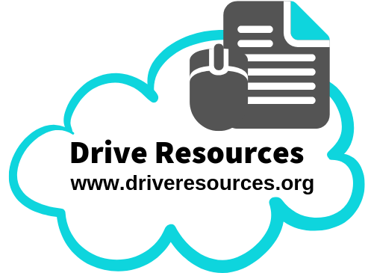
Self/Peer Assessment of Level 2 Literary Essays
‘Must do’ list! |  | Intro/  Concl | Para 1 | Para 2 | Para 3 | Para 4
Introduction | Title underlined/in quotation marks and full name of author/director given.
Introduction | Gives brief but clear synopsis (2 sentences max!)
Introduction | Makes reference to author/director purpose (discuss in relation to wider world/human behaviour) in relation to the question
Introduction | Begins with thesis statement. Statement includes:  - Key words from the question  - Your ‘answer’ (argument!) to that question / opinion about it;
Introduction | Outlines the 3-4 points that will be made in the essay, (and these points relate to each paragraph).
Each paragraph peels back layers of understanding | Make point in first sentence that uses key word(s) from the question.
Each paragraph peels back layers of understanding | Point made in first sentence is kept to throughout the paragraph (you don’t start writing about something else).
Each paragraph peels back layers of understanding | Specific and appropriate examples (evidence) from the text are given. Should include:  - Specific reference to something  - at least one quotation  - film technique (for film essays)
Each paragraph peels back layers of understanding | Explains how evidence supports the main point.
Each paragraph peels back layers of understanding | Link your point to bigger ideas from the text! Eg:  • The main idea that this illustrates (Compulsory!)  • What this shows about a character, event, mood…
Each paragraph peels back layers of understanding | Step outside the text! Eg:  • Author/director purpose (to…) (Compulsory!)  - What this tells you about the human condition/human behaviours.  • The historical context of the text  • How your point connects with something in a similar text  • Your personal response (our, we, us, readers/viewers)
Each paragraph peels back layers of understanding | Final sentence refers back to the question (and your point in that first sentence), using those key words again.
Conclusion | Succinctly sums up essay, distilling essence of essay into a brief paragraph. Do this by including:  - A statement offering final thoughts on thesis statement (ie your argument with regard to the question)  - Using key words from the question  - Referring briefly to key points discussed
Conclusion | Attention-grabbing
Conclusion | Does NOT begin with “In conclusion” or anything similar!

Mechanics / Technical Stuff | ‘Must do’ List! | Yep | Nope
Mechanics / Technical Stuff | Whenever theme is mentioned it is ‘named’ in full, in a sentence that makes sense. Hint: Use the word THAT.
Mechanics / Technical Stuff | You show perceptive, original thought.
Mechanics / Technical Stuff | Succinct (hits nail on the head). That is, uses academic language and extensive vocabulary precisely to make the message clear.
Mechanics / Technical Stuff | Uses the present tense.
Mechanics / Technical Stuff | Makes a clear, concise point in each sentence (avoiding waffle!).
Mechanics / Technical Stuff | Every sentence is complete.
Mechanics / Technical Stuff | Quotations are blended into your own sentence AND use double quotation marks (“xxxx”)
Mechanics / Technical Stuff | Makes use of connectives.
Mechanics / Technical Stuff | Spelling is correct – especially titles and authors/directors! (This includes correct use of capital letters.)
Mechanics / Technical Stuff | Apostrophes are used correctly.
Mechanics / Technical Stuff | Writing is legible.

